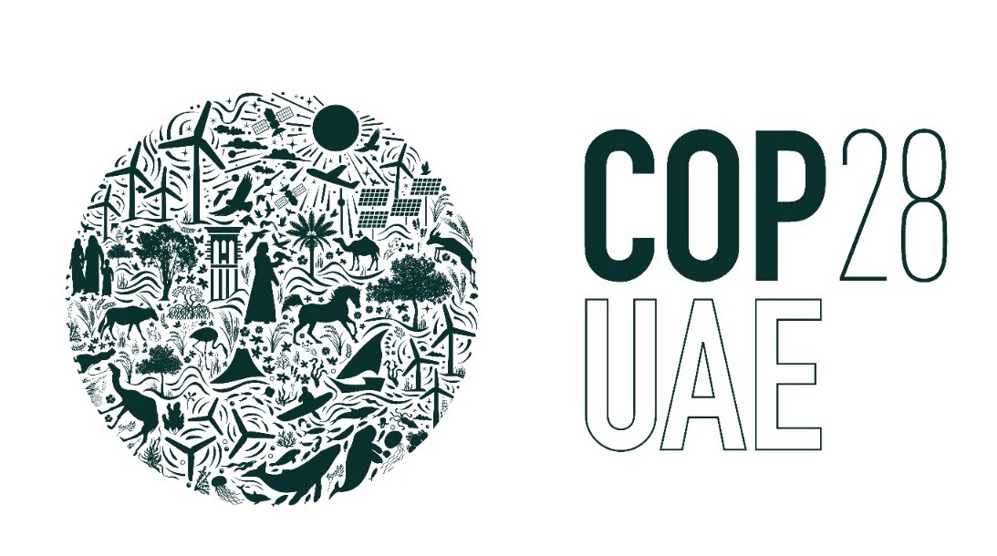
Praying for COP 28

“The climate emergency is a race we are losing, but is a race we can win” UN Secretary-General Antonio Guterres, September 2022.

COP28 is the 28th United Nations climate change conference - held this year in the United Arab Emirates, from 30 November to 12 December. It's a global conference bringing together governments, businesses, communities and faith-based organisations. Participants will be looking at the way climate change affects so many areas of our lives, including health, transport, buildings, food and nature. Alison Campbell is the UK’s lead climate negotiator.

The Church of England is sending a delegation representing the Anglican Communion from all
around the world, led by Archbishop Julio Murray, from Panama. The impacts of climate change - drought, storms and flooding - are not felt equally around the world. Some of the poorest communities in the world are suffering the most and Archbishop Julio wants to highlight this.

The siting of this year’s conference in an oil rich state with the Chair, Dr Sultan al-Jaber, himself a CEO of the Abu Dhabi National Oil Company – does not inspire confidence that serious changes to phase out fossil fuels will result. However, it could be argued that the best people to negotiate for this are those most closely involved. Time will tell. Nevertheless these COP conferences provide a key global forum where all countries can have a voice and be involved in negotiating the way ahead. And some, like Paris and Glasgow, have brought real encouragements.

There are various things we can do as Christians to support COP28 – these include raising awareness through our churches, praying with conviction and sharing our concerns with our local MP. There are some key outcomes we can hope for:
- Rapidly cutting carbon emissions to limit the rise in global temperatures to 1.5 degrees C
- Agreeing funds to make the changes needed and to support countries already facing irreversible loss and damage
- Putting nature, people, lives and livelihoods at the heart of climate action
- Making sure everyone has a voice, especially those who are not usually heard.

The conference ends with two days of negotiations to agree the final text between all nations. Everyone has to agree everything, so this part of the conference can get very tense and often overruns.

What can we pray for?
- We pray for world leaders to come with openness to listen to those most affected by climate change and to have the courage to act urgently and wisely.
- We pray for agreements on phasing out fossil fuels to cut carbon emissions and give some hope of limiting the rise in global temperatures
- We pray for funding to help countries adapt to the changing climate. In 2010, richer countries promised to mobilise $100bn a year to help tackle climate change. In 2022 a new fund to tackle loss and damage was announced. These targets have still not yet been met.
- We pray for the Church and Archbishop Julio and his colleagues: may they speak and act together in calling for climate justice and provide a voice for poorer countries.

(Green Christian will be holding a time of prayer every morning at 8am on Zoom during COP28 – all are welcome to join this.

Prepared by Isabel Carter with inputs from Pray and Fast for the Climate and
the Church of England.

